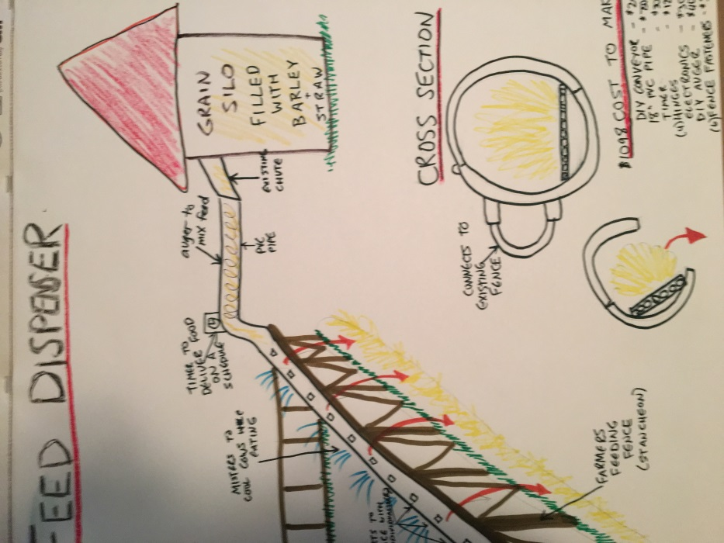
Spec Sheet - The Cow Feed Dispenser

Cost of Materials to Build Prototype

- DIY Converyor belt - $200
- 18" PVC pipe (10ft) - $750
- Timer - $10
- Industrial Hinges (4 per 10ft) - $12
- Misc Electronic Supplies (circuit borards, switches, sensors etc) - $30
- Auger - $40 to make
- Fence Fasteners (6 per 10 ft) - $36
- Total cost to Build - $1078 per 10 ft.

Sources

How to Make an Auger
https://www.youtube.com/watch?v=EZPIjRYt5Aw
https://www.youtube.com/watch?v=0K680_WeIVs

DIY Converyor Belt
http://www.instructables.com/id/DIY-Conveyor-belt/

Large Size PVC Pipe (18”)
http://www.usplastic.com/catalog/item.aspx?itemid=23979&catid=727

Electronics
http://www.frys.com/template/ecomponents

Attachment to the Fence, Hinges
http://www.homedepot.com/b/Lumber-Composites-Fencing-Chain-Link-Fencing-Chain-Link-Fence-Accessories/N-5yc1vZc3n6
http://www.homedepot.com/s/hinges?NCNI-5

